Camp 619 Beach Camp, Bangor, Caernarvonshire

Included in the 1945 ICRC Camp List – Labour Camp. 619. Beach Camp, Bangor, Caernarvonshire.

Location: NGR SH 5864 7281. The camp is just at the side of Beach Road.  Before the camp: King George V Playing Field. British military camp established with 40 Nissen huts. During 1944 used by American troops, including Joe Louis, the ‘Brown Bomber’, up until D-day.  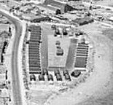  Pow Camp: Although the map shows the buildings as large blocks, an aerial photograph shows they were individual huts  (www.bangorlocalhistory.org).  Italian pows.  (Information from Adrian Hughes, of the Home Front Museum, Llandudno). “Six days a week the PoWs were taken by military vehicle to local farms where they worked on the land alongside farmers and members of the Women’s Land Army. In their spare time they created little gardens outside the huts and were popular in the local community, although some of the returning British soldiers and their families resented this fraternisation.”  Memories of Kenneth Gordon Thomas, who was nine years old in 1944; “The local population made a beeline for Beach Rd on a Sunday afternoon to look at the front of the Barracks decorated in sculpted and decorated gardens relating to the prisoners’ homeland, Italy. One that stands out was the 'Leaning Tower of Pisa'. It really was a day out. The PoWs were accepted for what they were, and no hatred was vented against them. They visited the local fish and chip shop, Valla, which was run by an Italian family who had been resident in Bangor for quite a number of years. My family invited a few of the PoWs to Sunday lunch, and I took an interest in learning their language.”  (From - historypoints.org/index.php?page=site-of-wartime-camp-beach-road-bangor) | 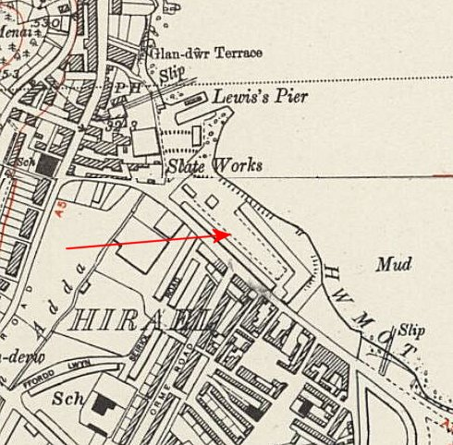
 | Ordnance Survey 1951

After the camp: Open space.

Further Information:

