Camp 618 Inveraray, Argyllshire

Location: A suggested NGR of NN 0893 0989 is to a site called ‘Malt Land’ about 1.5km NNW of Inverary.  Before the camp:  Pow Camp:  After the camp:  Further Information:  Camp listed on Secret Scotland website. | 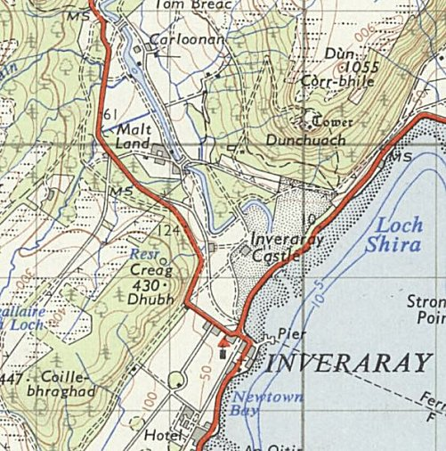
 | Ordnance Survey 1956

