Camp 617 Dryfeholme Camp, Lockerbie, Dumfrieshire (aka Halleaths)

Prisoner of War Camps (1939 – 1948) - Project report by Roger J.C. Thomas - English Heritage 2003
OS NGR | Sheet | No. | Name & Location | County | Cond’n | Type 1945 | Comments
 |  | 617 | Dryffeholme Camp, Lockerbie | Dumfrieshire |  |  | Scotland

Location: NGR NY 1015 8175. About 3.5km W of Lockerbie. Dryfeholme Farm is just over 2 km to the NE.  Before the camp: Farmland  Pow Camp: The Canmore site states that this was originally thought to be a military accommodation camp, but is in fact a German pow camp. It also states that, as the camp is visible on the 1941 air photograph, it was opened before June 1941.  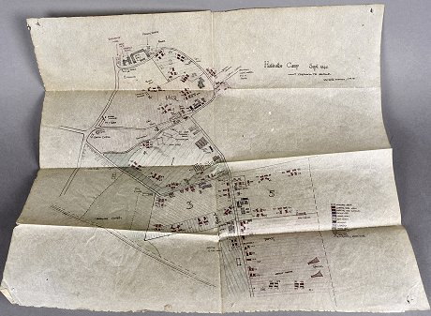  I think this is incorrect. In 2017 a hand-drawn map of Halleaths camp came up for auction. The map was dated September 1942. Although the catalogue image was a little hard to read, there are clear labels for: Gymnasium, Drill shed, Sleeping huts - men, NAAFI, Assault course and (firing) range. So, it was still a military site at that date. There are reports, (not confirmed) that the camp was used by Canadian troops.  At least 150 huts, mainly Nissen, on various sites in local area - from Halleaths Farm to the N on the map down to the railway line.  Listed by Canmore as a German pow Base Camp  After the camp: Part farmland, factory built on S section. | 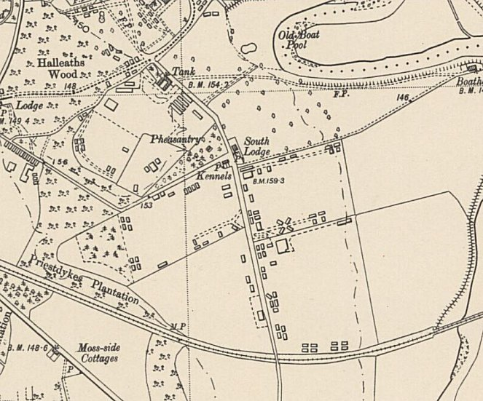
 | Ordnance Survey 1952
Further Information:
http://canmore.org.uk/site/174347
RAF WWII air photograph, F309, 5056-57, 26 June 1941
Air photographs, (541[A] 397, 3130-3132, flown 20 May 1948

