Camp 617 Castle Goring, Nr Little Hunstead, Worthing, Sussex

Included in the 1945 ICRC Camp List – Labour Camp. 617. Castle Goring, Nr.Little Hunstead, Worthing, Sussex.

Location: NGR for Castle Goring is TQ 1026 0562. However, the address is strange as I can find no reference at all to a ‘Little Hunstead’  Before the camp: Castle Goring Country House and estate. Requisitioned for use by the Canadian Army in WW2.  Pow Camp: Italian labour camp.  Information from Chris Hare, Director, History People UK – “You have unearthed a curiosity! I have never heard of Little Hunstead, and feel certain that no such place ever existed. There is a Little Horsted in East Sussex but I have never heard of it having a POW camp.  There certainly was a POW camp for Italians near Castle Goring, as the old woodman from Clapham and Patching who I got to know in the 1980's used to talk about it. Castle Goring itself was used by the military during WW2 but by the end of 1945 it had been occupied by squatters led by a woman known as 'Monty' because of the beret she wore being just like General Montgomery's.”  After the camp:  Further Information: | 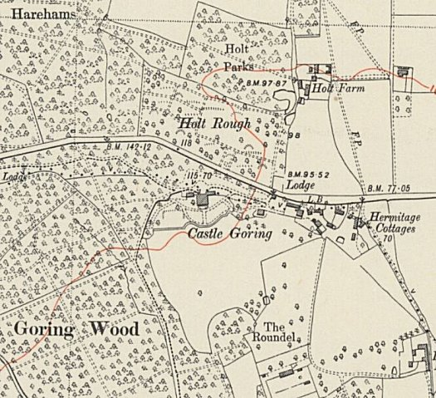
 | Ordnance Survey 1950

