Camp 615 Holmesdale, Nutfield, Nr Redhill, Surrey

Included in the 1945 ICRC Camp List – Labour Camp. 615. Address non communiqué.

Location: Holmesdale is located at NGR TQ 3092 5035  Before the camp: Country house and estate. Requisitioned for military use in WW2.  Pow Camp: Italian labour camp.  The book, ‘Nutfield Memories of World War II’ (Nutfield History Group, 2012) records Italian pows, (possibly Germans) at High Beech which is just 0.75km south of Holmesdale (TQ 3132 4970).  After the camp:  Further Information: | 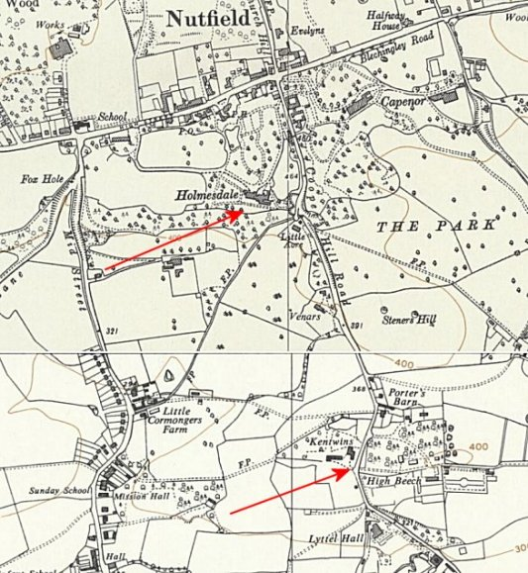
 | Ordnance Survey 1961

