Camp 613 Old Dalby Camp, Old Dalby Lane, Melton Mowbray, Leicestershire

1947 Camp List
613(G.W.Coy) | N | North Camp, Old Dalby, Nr.Leicester | Melton Mowbray 520 Ext.213 | 25(W.O.) | V/1456/2

Prisoner of War Camps (1939 – 1948) - Project report by Roger J.C. Thomas - English Heritage 2003
OS NGR | Sheet | No. | Name & Location | County | Cond’n | Type 1945 | Comments
SK 6879 2465 | 129 | 613 | Old Dalby Camp, Old Dalby Lane, Melton Mowbray | Leicestershire | 4 |  | Large complex of accomodation hutting associated with RAF Depot. NGR given to feature centre.

Location: About 9km NW of Melton Mowbray. One reference stated that the camp was where the Queensway residential area is now, that would place it to the East side of the camp near to where the map says Hatton Lodge..  Before the camp: Ordnance / storage depot and workshops with accommodation for civilian workers and military, mainly in Nissen huts – the smaller buildings shown to the N of Old Dalby Road.  Pow Camp: The pow camp was believed to have held about 300 pows, though the War Establishment number gives a capacity for about 1000.  After the camp: The depot closed in 1996.Old Dalby Business Park.  Further Information: | 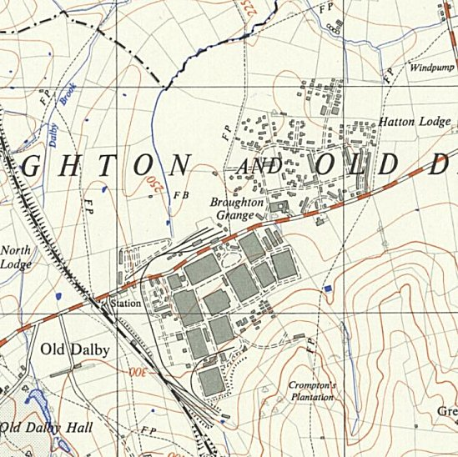
 | Ordnance Survey 1957

