Camp 613 Blackbeck Camp, Stainton, Co.Durham

Prisoner of War Camps (1939 – 1948) - Project report by Roger J.C. Thomas - English Heritage 2003
OS NGR | Sheet | No. | Name & Location | County | Cond’n | Type 1945 | Comments
NZ 0720 1793 | 92 | 613 | Blackbeck Camp, Stainton | County Durham | 5 | German Working Company | Precise location not identified, NGR given for Stainton Grove Camp. There were numerous camps in this area associated with the initial training of army recruits during World War II.

Location: NGR NZ 0688 1767  Before the camp: The large military camp was built in 1942. Blackbeck was on the edge of the military camp.  Pow Camp: BBC People’s War : “Blackbeck POW Camp was built… only a field away from the railway line and was known to the ICRC as a POW camp for German prisoners. It is said that prisoners snared rabbits in this field and taught some local youngsters this useful skill.  It can be seen on the RAF aerial photograph of 1946 but not on the 1945 photograph. A track led from Stainton Camp along the northern side of the railway embankment to Blackbeck Camp... Today the site is known as The Oval, Stainton Grove.” Article A7149666  After the camp: Residential area | 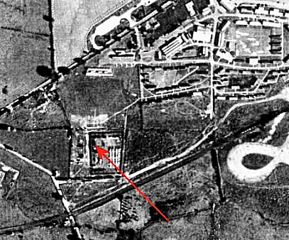 | 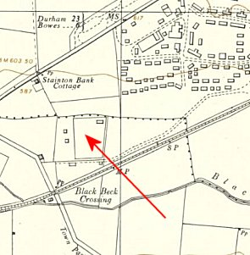
 | Aerial photograph 1946 | Ordnance Survey 1954
Further Information:

The snared rabbit story was in the Northern Echo, 10 November 2007.

