Camp 611 Harrold Hall, Harrold, Bedfordshire

Prisoner of War Camps (1939 – 1948) - Project report by Roger J.C. Thomas - English Heritage 2003
OS NGR | Sheet | No. | Name & Location | County | Cond’n | Type 1945 | Comments
SP 9489 5689 | 153 | 611 | Harrold Hall, Harrold | Bedfordshire | 5 |  | Precise location not identified, NGR given for cross roads.

Location: The camp was recorded as being in the grounds of Harrold Hall at NGR SP 954 567  Before the camp: Country house and estate. Hall used as a barracks for the Pioneer Corps from 1943.  Pow Camp: Italian pows. Dates believed to be 1944 to 1946.  After the camp: After a short time as a private residence, the Hall was demolished in 1961. 2020 residential area.  Further Information: | 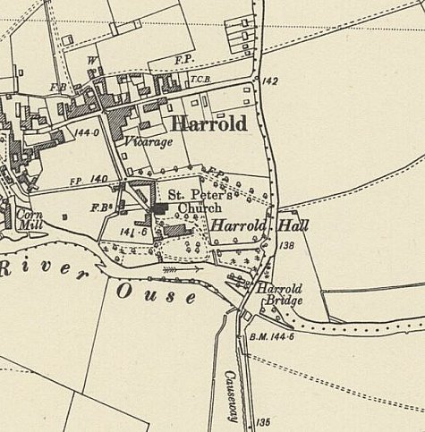
 | Ordnance Survey 1951

