Camp 608 (& 627) Royal Wanstead School, Wanstead, London E11

Included in the 1945 ICRC Camp List – Labour Camp. 608. Address non communiqué. Also ICRC – Labour Camp. 627. Royal Wanstead Schools, London E11.

Location: NGR TQ 3985 8881  Before the camp: An ‘Infant Orphan Asylum’, later renamed the Royal Wanstead School. Some military use in WW2 - there is a picture of Lord Lyell with the 1st Battalion Scots Guards on parade in 1942. Do not know if the camp was inside the building or the grounds.  Pow Camp:  After the camp: The school closed in 1971. The site now listed as a Crown Court.  Further Information: | 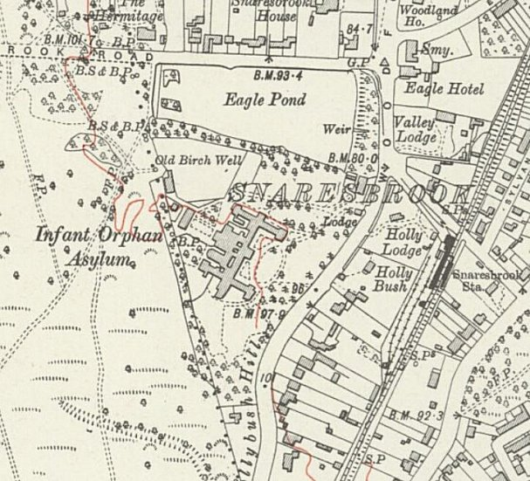
 | Ordnance Survey 1932

