Camp 607 Hutted Camp, Ickleton Grange, Ickleton, Essex

Included in the 1945 ICRC Camp List – Labour Camp. 607. Hutted Camp, Ickleton Grange, Saffron Walden, Essex.

Prisoner of War Camps (1939 – 1948) - Project report by Roger J.C. Thomas - English Heritage 2003
OS NGR | Sheet | No. | Name & Location | County | Cond’n | Type 1945 | Comments
TL 4528 4291 | 154 | 607 | Hutted Camp, Ickleton Grange, Ickleton | Essex (Cambridgeshire) | 3 |  | Site situated in woodland.

Location:  Before the camp:  Pow Camp:  After the camp:  Further Information: | 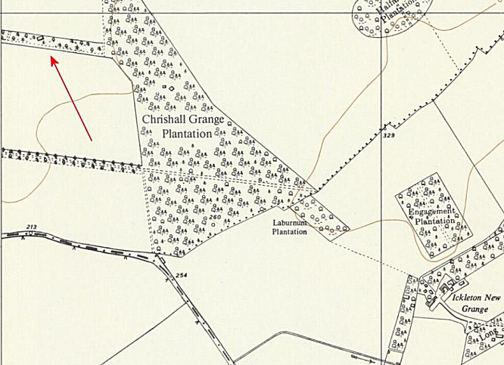
 | Ordnance Survey 1960

