Camp 606 Bineham, Nr Chailey, Sussex

Included in the 1945 ICRC Camp List – Labour Camp. 606. Bineham, Nr.Chailey, Sussex.

Location: Bineham was NGR TQ 3879 1993. Bineham Farm is alongside. About 7km W of Burgess Hill  Before the camp:  Pow Camp:  After the camp: The building called ‘Bineham’ does not show on modern OS map.  Further Information: | 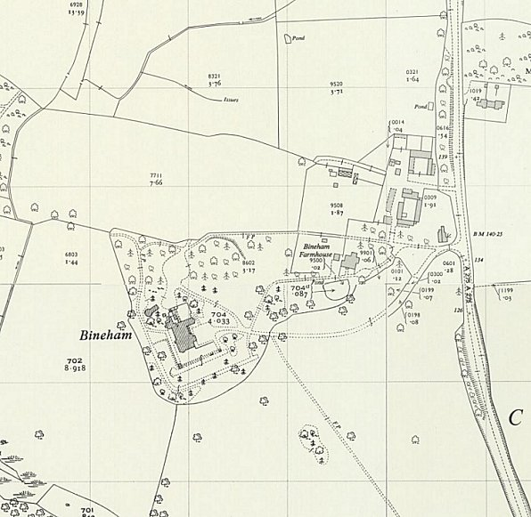
 | Ordnance Survey 1957

