Camp 605 West Boldon Camp, Down Hill Quarry, Sunderland, Co.Durham (+ East Boldon)

Prisoner of War Camps (1939 – 1948) - Project report by Roger J.C. Thomas - English Heritage 2003
OS NGR | Sheet | No. | Name & Location | County | Cond’n | Type 1945 | Comments
NZ 3475 6025 | 88 | 605 | West Bolden Camp, Down Hill Quarry, Sunderland | County Durham | 5 |  | Precise location not identified, no obvious features visible on aerial photographs. NGR given for centre of quarry.

Location: Lime quarries next to Downhill Farm, just S of West Boldon.  Before the camp: Quarry  Pow Camp: Italian pows recorded, though the nearby East Boldon camp had Italian and then German pows. About 14 Nissen huts in the centre of the north lime quarry and some other buildings near to the entrance from the road.  After the camp: 2020 dis-used quarry  Further Information:  Website about the Boldon area during the war, includes aerial photo taken in 1946 – www.boldonwm.uk  Aerial Photograph RAF 106G/UK/1193 4362 27-FEB-1946 | 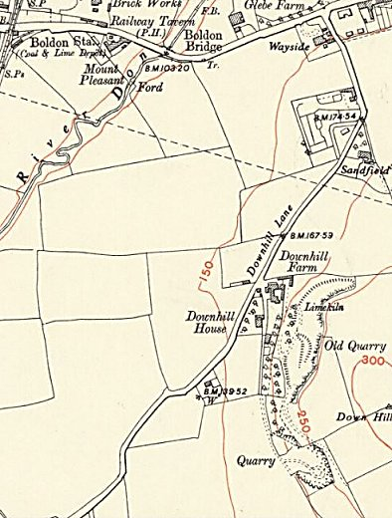
 | Ordnance Survey 1952

- - - - - - - - - - - -

East Boldon Camp

NOTE – I do not know that the East Camp had any links to the West Camp, but they were very close together (2 km).

It may be that as the Italian Camp at West Boldon closed, this camp for German pows opened up. The East Boldon Camp was ‘associated’ with Camp 139 Wolviston Hall.

East Camp – NGR NZ 3687 6063. Only a small part of the Anti-Aircraft site and Ordnance Depot shown on the map.

The records I have seen only relate to German pows.  The camp was inspected on behalf of the Control Office for Germany and Austria (COGA): Reformatted leaving out blank spaces -  ENGLISH INSPECTOR’S REPORT – Mr R D Miller  DATE OF VISIT – 20-21 Sec [?] 1947  CAMP NO. 8 POW Platoon TYPE: Working  ADDRESS No.8 POW Platoon, Attached to No.20 B.D. Squadron, R.E., The Hutted Camp, East Boldon, Northumberland. [These attachment details are crossed out in red crayon].  TELEPHONE: Boldon 7796  COMMANDANT: Major W M Browne  LAGERSPRECHER: Neumann, W. [Pow spokesman]  No OF HOSTELS one detachment  STRENGTH OF MAIN CAMP 61 GERMANS/AUSTRIANS TOTAL STRENGTH 107  STRENGTH OF HOSTELS 46  No IN HUTS. ALL  WELFARE FUND: £40  LONDON TERMINUS: Kings Cross STATION OF ARRIVAL: East Boldon  DISTANCE FROM STATION TO CAMP: half a mile  COMMUNICATION FROM STATION TO CAMP: foot  ACCOMMODATION: Mess | 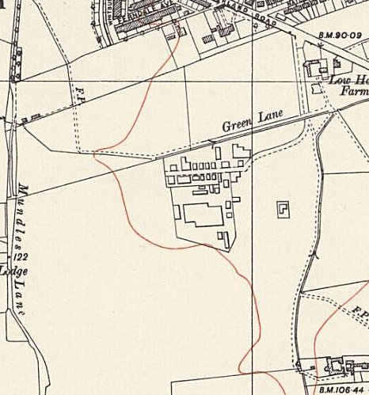
 | Ordnance Survey 1951

ENGLISH CLASSES – beginners – 9 pupils; 1 class; 2 lessons per week; Lesson reached in GOS; 12
Total GOS in Main Camp 50 (including 25 at HQ)

Classrooms: one – hut – electric lighting – stove heating – one blackboard. Dining room used for lectures.
No of English book in library 20 ENGLISH FOR ALL.

Hostel: South Gare Detachment near Redcar, Yorks – hostel visited. 50 miles from camp; strength 46.
12 beginners – 2 lessons per week – 1 teacher – No of GOS 25 – 2 blackboards – rec room – electric light – stove heating 13 ENGLISH FOR ALL from Wolviston. 12 English books.

Reception. The reception by the Commandant, Major Browne, was very friendly. Transport was made available to visit the detachment.

Main Camp. The teacher, Pechmann, H P, is a university man and has a very good knowledge of English, having studied it at the University. He has a class of beginners, and it is a class which never gets beyond the beginner’s stage because of frequent comings and goings in the camp. At present he has nine pupils. At the main camp I gave a talk on “English and German Compared”.

Detachment. The South Gare detachment is likewise fortunate in having a teacher who is also a university man and has a good knowledge of English, Sadee H D. Owing to the unfavorable circumstances – it was a Sunday when I visited the detachment – I was not able to give a talk to the detachment.

Candidates for Examination. At East Boldon there are at least two Ps/W who would like to sit for our English examination, which has not yet been held at this camp, and at South Gare there are at least three prospective candidates.

Expected Move. I understand that the camp expects to move about the middle of January to a place in Yorkshire not yet known. The new location could be obtained from Wolviston Hall Camp (139) (near Stockton-on-Tess), to which the present camp is attached for some purposes.

Deferred Repatriation. I understand that about half a dozen Ps/W at East Boldon have applied to have their repatriation deferred for a year.

East Boldon was owned by the MOD and remained in use well into the 1950s.

In 2019 there was a campaign to turn the site into a WW2 Heritage centre.

National Archives – FO 939/90 – ‘8 PW Platoon, The Hutted Camp, East Boldon, Northumberland’ – dated 1947 (see above)

