Camp 605 Urpeth Lodge, Birtley, Co.Durham

Included in the 1945 ICRC Camp List – Labour Camp. 605. Urpeth Lodge, Birtley, Co.Durham.

Location: Urpeth Lodge is located at NGR NZ 237 540. It is close to the Beamish Museum.  However, a HER entry (HER 5563) gives a general location of NZ 27 57, this is 4.7 km to the NE of the Lodge.  Before the camp: Country House. Searchlight Battery manned by the 225th Anti Aircraft Artillery (Searchlight Batallion) USA until May 1944.  Pow Camp: Low security Italian labour camp.  After the camp:  Further Information: | 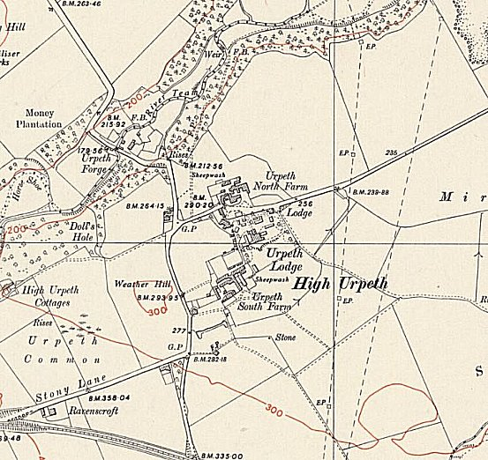
 | Ordnance Survey 1951

