Camp 601 (& 690) Thomas Street Camp, Selby, Yorkshire

Included in the 1945 ICRC Camp list – Labour Camp. 601. Thomas Street Camp, Selby, Yorkshire.

1947 Camp List
690(G.W.Coy) | N | Thomas Street Camp, Selby, Yorks | Selby 314 | 14(W.O.) | V/1270/4

Prisoner of War Camps (1939 – 1948) - Project report by Roger J.C. Thomas - English Heritage 2003
OS NGR | No. | Name & Location | County | Cond’n | Type 1945 | Comments
SE 6188 3255 | 690 | Thomas Street Camp, Selby | Yorkshire | 5 | German Working Company | Precise location not identified. NGR for Thomas Street.

Location: Thomas Street is a small road – not much space to put a pow camp. My first thought was it may have been at the site where the Barlby Bridge Primary School is – but records state that the school was opened in 1925.  Before the camp:  Pow Camp:  After the camp:  Further Information: | 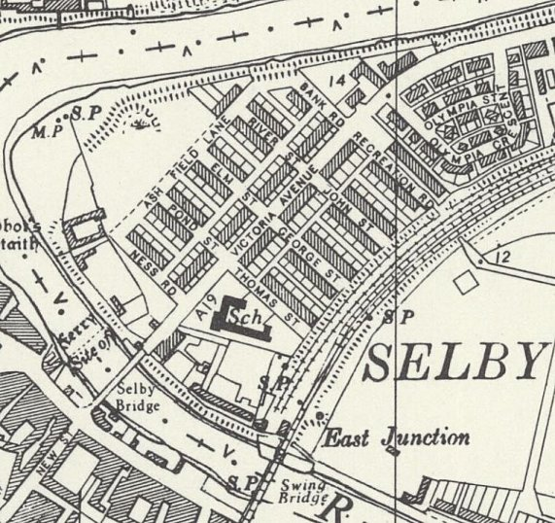
 | Ordnance Survey 1958

