Camp 600 Pennings Camp, Wiltshire

Included in the 1945 ICRC Camp list – Labour Camp. 600. Pennings Camp, North, Wiltshire.

Location: I think the incomplete address ‘North’ above, would be ‘North Tidworth’.  The Pennings area shown on the map is on the edge of North Tidworth. Barracks were recorded in the area during WW1. The group of huts shown roughly in the centre of the map are possibly the site used at NGR SU 228 505.  Before the camp: Wikipedia – “Pennings camp was established in August 1917 and was occupied by New Zealand Rifle Brigade reserves when Sling Camp became full”. At the place where the huts are shown, on a 1923 map, there were just two huts described as ‘Telephone Hut’.  Pow Camp: Italian labour camp.  After the camp:  Further Information: | 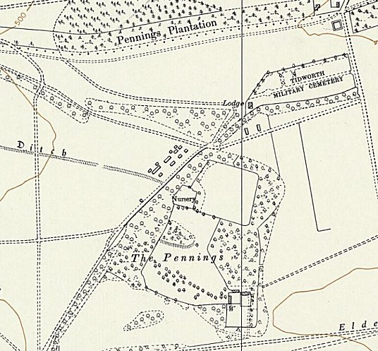
 | Ordnance Survey 1961

