Camp 598 Country House Hotel, Sidford, Devon

Prisoner of War Camps (1939 – 1948) - Project report by Roger J.C. Thomas - English Heritage 2003
OS NGR | Sheet | No. | Name & Location | County | Cond’n | Type 1945 | Comments
SY 1336 9004 | 192 | 598 | Country House Hotel, Sidford, Sidmouth | Devon | 5 |  | Precise location not identified, NGR given for cross roads.

Location: School Street, Sidford. NGR SY 134 901  Before the camp: Late 18th / 19th C house. Hotel. National Heritage List: Country House (Flats Nos 1, 2, 3). Some alterations. 3 storeys rough- cast. Low pitch gable end slate roof.  Pow Camp:  After the camp: 2020 Country House is listed as a care home.  Further Information: | 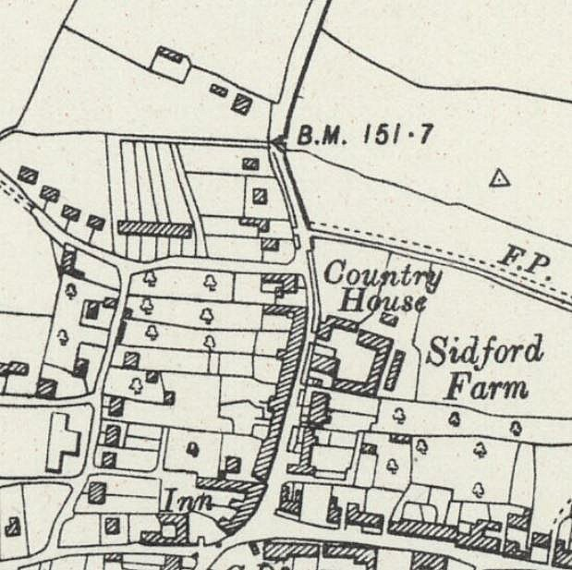
 | Ordnance Survey 1944

