Camp 596 Nine Yews Camp, Cranborne, Dorset

Included in the 1945 ICRC Camp list – Labour Camp. 596. Nine Yews Camp, Cranborne, Blandford, Dorset.

Location: Nine Yews House is about 2 km W of Cranborne.  Before the camp:  Pow Camp:  After the camp:  Further Information: | 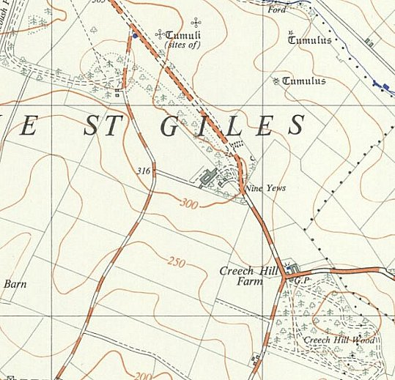
 | Ordnance Survey 1961

