Camp 596 East Deanston, Doune, Perthshire

Location: Disputed  Information from Secret Scotland website – ‘Actually Deanston House, Deanston.’ NGR NN 7139 0142. Camp within the grounds of the house – possibly some huts shown on the map.  However, others state it was at the site of Creity Hall Guest House – which was called East Deanston - the name the camp was known by, (shown bottom right corner of map).  My guess – it was both. East Deanston probably used as offices and postal address (and possibly as pow hostel), with huts in the larger grounds at Deanston House. There are memories of huts, and photos of Italian graffiti still to be seen carved into trees in the Deanston House grounds in the 1980s, (see entry by ‘MyOldDad’ at ww2talk.com).  Before the camp:  Pow Camp: Italian pows  After the camp: Deanston House had mixed use. 2020 it is a care home.  Further Information: | 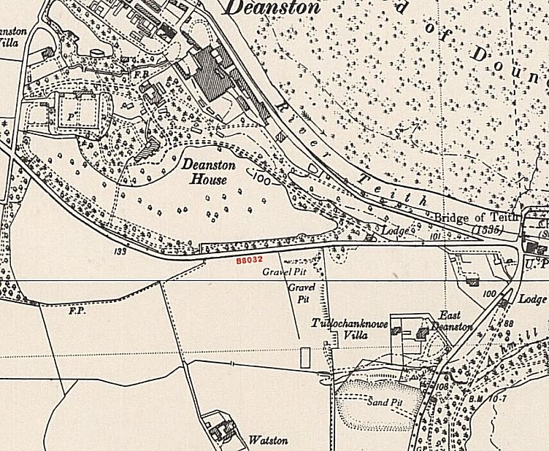
 | Ordnance Survey 1950

