Camp 593 Rob Roy Camp, Aberfoyle, Stirling

Included in the 1945 ICRC Camp list – Labour Camp. 593. Address non communiqué.

Location: Alongside the A81 – NGR NN 5315 0015  Before the camp: Farmland and woods  Pow Camp: Italian and then German pows. Believed to have been built c1943.  After the camp: 2020 Rob Roy Motel  Further Information: | 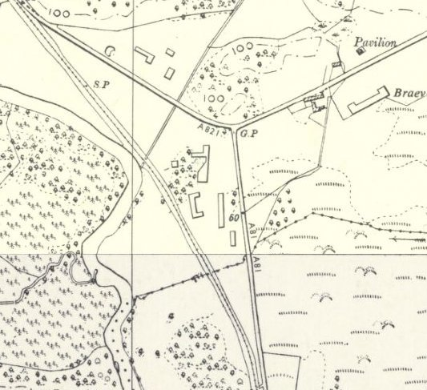
 | Ordnance Survey 1958

