Camp 592 Royal Alexandra School, Duxhurst, Reigate, Surrey

Included in the 1945 ICRC Camp list – Labour Camp. 592. Royal Alexandra School, Duxhurst, Reigate, Sy.

Location: The camp was not at the school, but on land belonging to the school. NGR TQ 257 452. Just off the Reigate Road.  Before the camp: The Industrial Farm Colony for Female Inebriates by Duxhurst was founded in 1895 by Lady Isabella Somerset to care for women alcoholics. In 1923 the Colony became the Princess Marie Louise Village of Gentlefolk. In October 1936 the estate was put up for sale, and was finally sold in 1938 to the Royal Alexandra Orphanage (& school). At the start of WW2 the site was used as an officer cadet training centre, and then a pow camp.  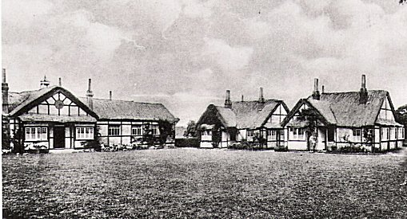  Pow Camp: Italian pows.  Postal items seen – 2 x pow letter-sheets dated 1944 and 5 October 1944 to Italy  <Colony buildings. I expect that tents and/or huts were also built in the large estate.  After the camp: The Colony buildings were demolished.  Further Information: | 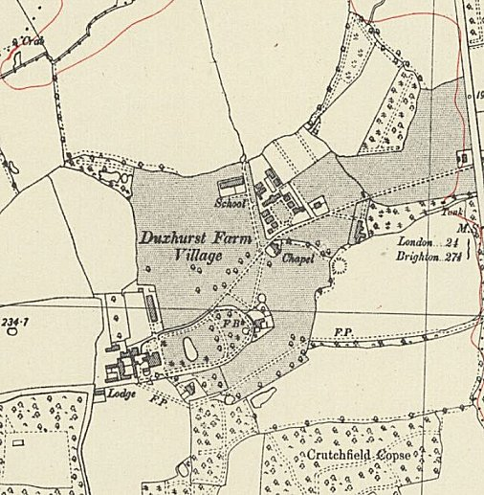
 | Ordnance Survey 1944

