Camp 590 Hathern Camp, Pear Tree Lane, Hathern, Leicestershire

Prisoner of War Camps (1939 – 1948) - Project report by Roger J.C. Thomas - English Heritage 2003
OS NGR | Sheet | No. | Name & Location | County | Cond’n | Type 1945 | Comments
SK 5076 2092 | 129 | 590 | Hathern Camp, Pear Tree Lane, Hathern | Leicestershire | 4 |  | Farmland

Location: Camp shown on the 1955 map. On the NW edge of Loughborough  Before the camp:  Pow Camp: Italian pows.  It is believed that this camp was/or became a sub-camp of Garenden Camp 28.  After the camp: 2020 part residential, part open space.  Further Information: | 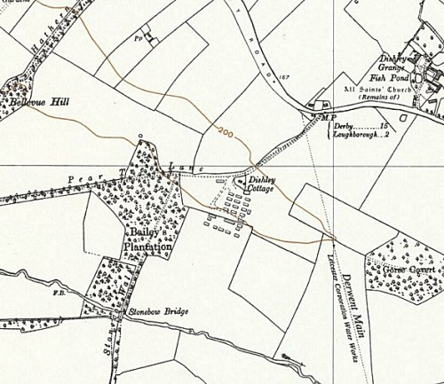
 | Ordnance Survey 1955

