Camp 589 Pylewell House, South Baddesley, Hants

Included in the 1945 ICRC Camp list – Labour Camp. 589. Pylewell House, South Baddesley, Nr.Lymington, Hants.

Location: The NGR for the house is SZ 3536 9582  Before the camp: Country House and estate. The whole county was under heavy military use. Part of the estate was used as an airstrip.  Pow Camp: Located in the grounds. Italian pows.  After the camp: Private estate and parkland.  Further Information: | 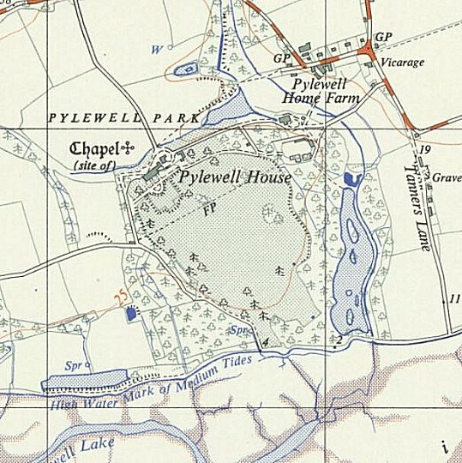
 | Ordnance Survey

