Camp 588 (& 622) Shapley House, Winchfield, Hants

Included in the 1945 ICRC Camp list – Labour Camp. 588. Shapley House, Winchfield, Hants. Also as Labour Camp. 622. Shapley House, Hartley Wintney, Hants.

Location: Shapley House is just off the London Road at NGR SU 7522 5535. Between Winchfield and Harley Wintney.  Before the camp:  Pow Camp: Italian pows.  After the camp: Shapley House was converted to flats.  Further Information: | 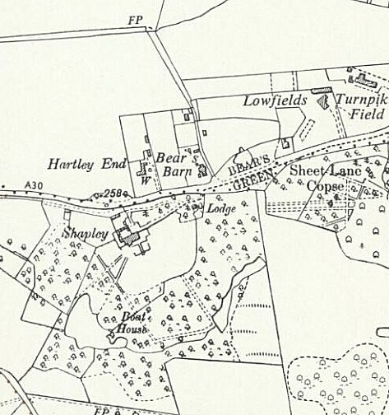
 | Ordnance Survey 1962

