Camp 587 Whitehill Camp, Wootton Bassett, Wiltshire

Included in the 1945 ICRC Camp list – Labour Camp. 587. White Hill Camp, Wootten Bassett, Swindon, Wilts.

Location: To the E of Swindon. Approximate location of camp according to description below is shown, (Beaumaris Road NGR SU 1192 8405).  Before the camp: Farmland  Pow Camp:  Memories of Mary Morse – “Mary had vivid memories of living at Whitehill Farm during the Second World War when a camp with a hundred soldiers was billeted on one of the fields. 377 Battalion, followed by 419 Battalion and later both German and Italian prisoners of war camped there. Three antiaircraft guns and a machine gun were erected in this field (which is now the site of Beaumaris Road) and Mary recalled seeing a Messerschmidt plane fly so low she could see the pilot.  There was no NAAFI for the soldiers billeted at Whitehill so Mary’s mother provided them with provisions while the officers used the farm parlour as a living room. Mary recalled the camp dances and celebrating her 21st birthday in one of the Nissen huts.”  (https://friendsoflydiardparkblog.wordpress.com/tag/whitehill-farm/)  After the camp: 2020 Residential area.  Further Information: | 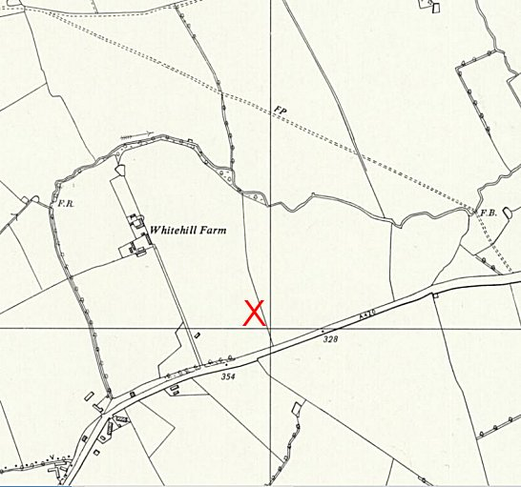
 | Ordnance Survey 1960

