Camp 586 Chard Hutted Camp, Chard, Somerset

Included in the 1945 ICRC Camp list – Labour Camp. 586. Chard Hutted Camp, Chard, Somerset.

Location: ?  Before the camp:  Pow Camp:  After the camp:  Further Information:  A request for information raised a camp at Chard Junction which is 4.5 km away from Chard – Approx NGR ST 3415 0439 | 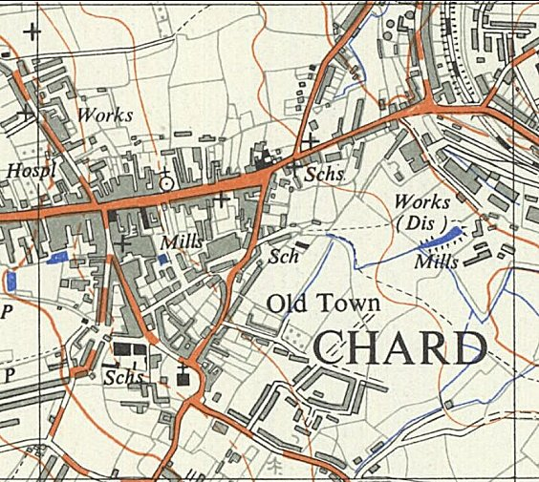
 | Ordnance Survey 1962

