Camp 584 Carfax Avenue, Tongham, Hampshire

NOTE – 1945 ICRC Camp list has – Labour Camp. 584. Larchfield, Runfold, Farnham, Surrey.

Prisoner of War Camps (1939 – 1948) - Project report by Roger J.C. Thomas - English Heritage 2003
OS NGR | Sheet | No. | Name & Location | County | Cond’n | Type 1945 | Comments
SU 8900 4888 | 186 | 584 | Carfax Estate, Tongham | Hampshire | 4 |  | Gardens and woodland

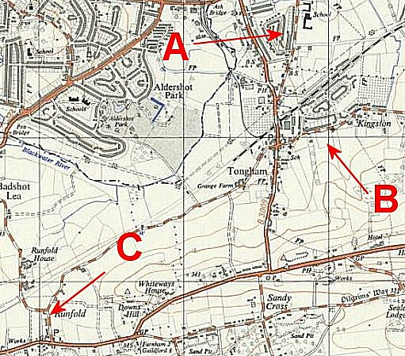 | Location: Despite the completely different entries above, I believe they were the same camp.  A – the location of Carfax Avenue / Estate, also shown enlarged to the right and the Avenue highlighted. This matches the descriptions below. NGR SU 886 497  B – the site for the NGR listed by English Heritage. This does not match the site description below. (+Tongham is in Surrey, not Hampshire.)  C – Larchfield was a large house used by the army just S of Runfold. It is 1.5 km SW of Carfax Avenue. NGR SU 871 477  I think that C was a sub-camp of A with other houses there. | 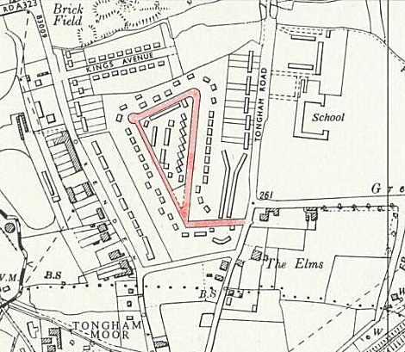
 |  | Ordnance Survey 1961
Before the camp:
Pow Camp: Italian pows at A, I have seen no reference to German pows here. At C, Italian, and then German pows are mentioned.
Article ‘The Crucifix in the Bottle’ by John Ades:

“In 1943, a number of Italian Prisoners of War were kept at Carfax Avenue, (then called Raytone and Princes Avenue). The prisoners lived in the houses surrounding Carfax Avenue and their administrative offices and cookhouse were in the centre triangle which now has flats and houses, and before that had prefabs.

As a young child I recall going to visit the Italians at meal times and eat Italian dishes with them. They also made us leather belts with coloured cable and toys now sadly gone. When I used to go to mass at the Holy Angels in Ash, the prisoners would march to mass singing as they went. They filled one side of the church and their hymn singing was very good.

There was a Belgian lady who lived at 79 Oxenden Road who became friendly with them. It was POW Annunziata Alfonso who made the crucifix in the bottle dated 12.3.1944. The bottle was made specially for Mrs Buxton. In her later years she gave the bottle to me as she knew I recalled the POWs from my childhood.

The Italian Medical Officer was very good at treating us young children when we had cuts and grazes. My recollection is that the prisoners had a very good imprisonment in Carfax, with most of them working on the land in the locality or in the Aldershot and Farnborough Barracks.

The bottle has on it what I believe to be holly leaves. I donated the bottle to Ash Museum as a memento of the Italians and my young childhood days which were happily spent with the friendly prisoners of war.” http://www.ashmuseum.org.uk/crucifix.htm

Other memories - “I had a next-door neighbour Tony, who was two years older than I and he took me to see his new school. We had by this time Italian prisoners of war behind our bungalows. They were living in a new council housing estate that had not been completed at the start of war. Anyway, mother had the prison camp turned out when we had not returned by night fall. When we returned and found no one at home we just sat on the front step. When mother did eventually return, I said, “Where on earth have you been? I have been waiting ages!” During this visit to the School I had smoked my first cigarette! Soldiers had all thrown their cigarettes out of the back of the TCV (Troop Carrying Vehicle) and Tony and I had tried them. I was very sick!
The Italian prisoners were not guarded and I spent a lot of time with them. I would sometimes eat with them. They appeared to eat a lot of radish and it was far too hot for me. I would get under the table and they would pass the radish down to me but I would still not eat it. Two of the Italians - their Doctor and their Cook would buy a slither of soap off you for Sixpence soap being very difficult to come by. The trick was every time you visited a house you would make an excuse to use the toilet whether you wanted to or not. Despite being told not to waste soap each time — if there was only a slither there — you would steal it and sell it to the Italians! The Italians were engaged on manufacturing simple electronic assemblies. They made us all belts out of the twisted plastic wires of many colours — they were very artistic.” By Peter Currie BBC PeoplesWar – Article A5892249

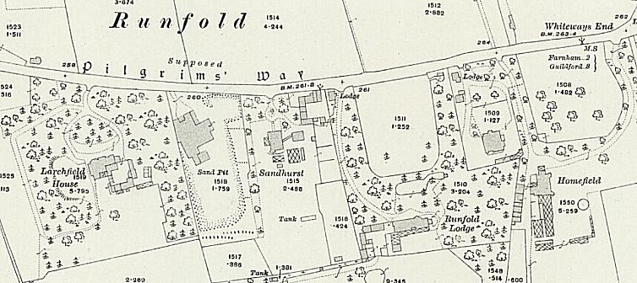
At Runfold several large houses were requisitioned during the war. They held British and Canadian troops and some were used to accommodate pows after D-day. Apart from Larchfield, there is a record of another large house with pows - “In about 1949 my father purchased a large Victorian house called Homefields. It was situated at Whiteways corner in Runfold, near Farnham Surrey. It had been requisitioned by the Army for the duration of the war and I knew it well, having played there for years when the Canadian soldiers were stationed in it. At the end of the War there had been Italian, then German prisoners of war at this house. There had been no bars or barbed wire to keep them there. I found the Germans very interesting and playful. They carved wooden toys; one which they gave me was like a ping pong bat with four little chickens on it. When you swung the ball hanging below the bat the chicken pecked the bat in rotation.” By Michael Bartholomew-Biggs - londongrip.co.uk/2016/12/the-gun/

< Requisitioned area and houses – Larchfield at one end, Homefield at the other.

After the camp:
Further Information:

