Camp 582 Sandy Warren Camp, Sandy, Bedfordshire

Included in the 1945 ICRC Camp list – Labour Camp. 582. Sandywarren Camp, Sandy, Bedfordshire.

Location: Sandy Warren is on the SE edge of Sandy. For camp location see below.  The book ‘Prisoners of War in Bedfordshire’ by Stephen Risby, states that the camp was between St Neots Road and London Road, which would place the camp in Sandy, rather than on the Warren. This may be a street name issue as St Neots Road runs into Potton Road and the probable site of the camp is between Potton Road and London Road.  Before the camp: The Warren had a lot of military units including a Searchlight Unit, Ammunition Depots and, possibly, a light Anti-Aircraft unit.  Pow Camp: Italian and then German pows.  Information received from from the RSPB Lodge reserve based on LiDAR and Hyperspectral data, post-war aerial photographs and interviews with soldiers who had served at The Lodge during wartime:  ‘Two soldiers mention the existence of the camp on the Stratford Road, on the south side of the reserve, while one also talked about both Italian, and later German, prisoners being housed by Cottage Farm, (see map). There is LiDAR evidence of 3 long, narrow huts, placed end to end, between Cottage Farm, Stratford Road and the road at NGR TL 1884 4758.  One soldier also thought there were 3 or 4 huts on Everton Road, Swaden, further N of Sandy Warren, (possibly a sub-camp NGR approx. TL 186 493).’ | 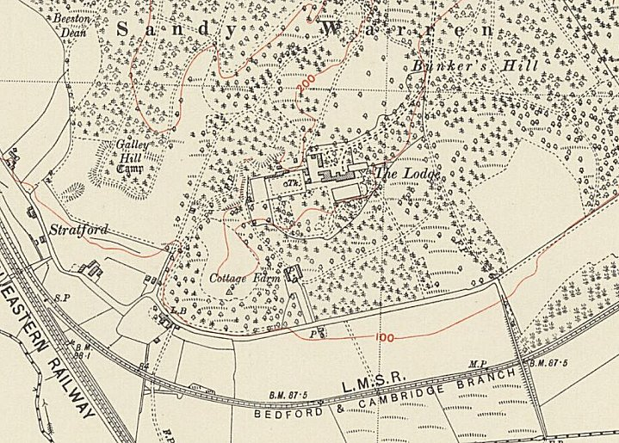
 | Ordnance Survey 1956
Pows assisted clearing the ammunition stores after the war.
Postal items recorded – Italian pow mail 13.1.1945 / 22.11.1945 (Forces Postal History Society).
The camp is likely to have closed during 1946 – it is not included in the list of re-educational survey visit reports for 1946 (FO 1120) or the 1947 Wilton Park camp list.
After the camp: Site of Special Scientific Interest on the SE edge of Sandy owned by the RSPB
Further Information:

