Camp 582 Blairvadach Camp, Rhu, Helensburgh, Dunbartonshire

Prisoner of War Camps (1939 – 1948) - Project report by Roger J.C. Thomas - English Heritage 2003
OS NGR | Sheet | No. | Name & Location | County | Cond’n | Type 1945 | Comments
 |  | 582 | Blairvadach Camp, Rhu, Helensburgh | Dumbartonshire |  |  | Scotland

Location: NGR NS 2617 8517. On the SW edge of the grounds of Blairvadach House. – possibly a few huts left shown on the 1958 map.  Before the camp: Large house and grounds.  Pow Camp: At least 40 mainly Nissen huts between the driveway to the House and the old route for the A814. German pows. (Some vague references to Italian pows).  News article about the camp – ‘…there was a great response to the appeal in Eye on Millig last week from Malcolm Sanders for information about camp no.582 at Blairvadach, more or less on the site of the existing outdoor centre but south of the existing road — although it was north of the original shore road.  Garelochhead reader Mrs Fiona Hamilton remembers it well, and confirms that it was classed as a work camp for the German servicemen.  She tells me: “The prisoners were sent out to farms, gardens and various other work places as there was a shortage of workers as the men had been recruited into our own services. I knew this camp well, as my father was gardener at the Eda Yarrow Home just along the road...  Mrs Hamilton says that there were other work camps, one at the top of Glen Fruin at the Garelochhead end, and another at Whistlefield.’ (Helensburgh Advertiser)  After the camp: The 40 Blairvadach Nissen huts then became temporary accommodation while new housing was built in Rhu, Garelochhead and Cardross. 2020 part of the site lost to A814 road, part Outdoor Centre. | 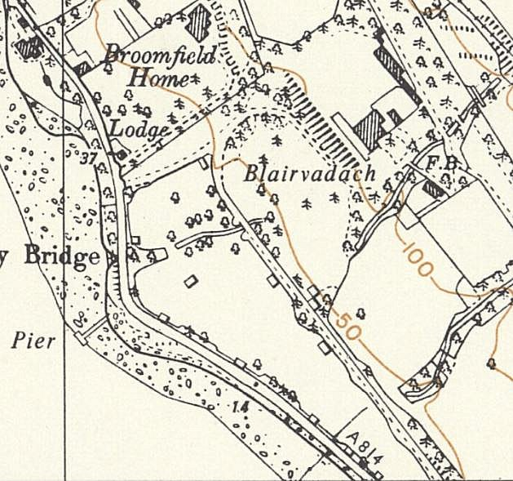
 | Ordnance Survey 1958
Further Information:
Canmore - http://canmore.org.uk/site/272621
Aerial photographs 106G/Scot/UK 85, 4147-4149, flown 10 May 1946

