Camp 581 (& 632) Arena Road Camp, Tidworth, Hants

Included in the 1945 ICRC Camp list – Labour Camp. 581. Arena Road Camp, Tidworth, Hants.

Prisoner of War Camps (1939 – 1948) - Project report by Roger J.C. Thomas - English Heritage 2003
OS NGR | Sheet | No. | Name & Location | County | Cond’n | Type 1945 | Comments
SU 226 480 | 184 | 632 | Arena Road Camp, Tidworth | Hampshire | 5 |  | Precise location not identified. NGR given for approx. centre of Tidworth Barracks.

Location: Location identified by Martin J Richards – www.systonimages.co.uk  “…the camp referred to as Arena Road was just off South Drive, a road that leads to Tidworth House which is now used as a Military Rehab Facility and lies within Tidworth Park. The actual Arena Road has now gone and there is a field that is currently used to graze horses.”  Another camp located nearby – 668 Aliwell.  Before the camp: The ‘arena’ was probably where the Tidworth Tattoo was held. Various brief references to troops at Arena Road Camp, including Australian forces.  Pow Camp: Italian labour camp.  One line reference to the camp being a ‘USSR Working Company’ – but no details as to whether this was as a pow camp, or afterwards.  After the camp: In the House of Commons:  “Mr Hollis asked the Secretary of State for War whether, in view of the acute housing situation caused in Tidworth by the eviction of non-service tenants from War department houses, the disused camp at South Tidworth will be placed at the disposal of those tenants for temporary accommodation.  Mr Shinwell - The camp at South Tidworth known as Arena Road Camp has been offered on loan terms to the local authority for two years to house families evicted from married quarters in the district. The offer is subject to review at the end of this period, and I understand that the local authority has accepted the camp on these terms.” Hansard Debate 21 January 1948, Vol 446.  Further Information: | 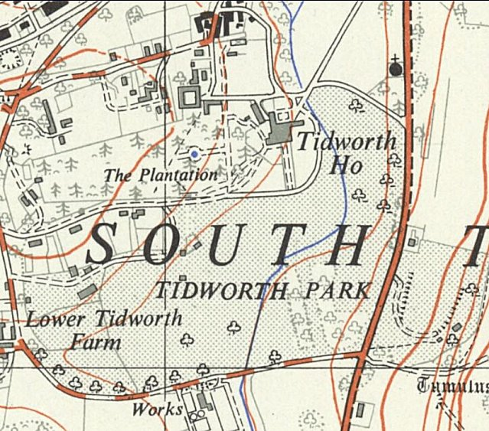
 | Ordnance Survey 1958

