Camp 577 (& 1014) Ordnance Depot, Queensferry, Flintshire

Included in the 1945 ICRC Camp list – Labour Camp. 577. No 70 C.O.D. (Don), Queens Ferry, Chester.

Prisoner of War Camps (1939 – 1948) - Project report by Roger J.C. Thomas - English Heritage 2003
OS NGR | Sheet | No. | Name & Location | County | Cond’n | Type 1945 | Comments
 |  | 1014 | Ordnance Storage Depot (O.S.D.), Queensferry | Flintshire |  | German Working Camp | Wales

1947 Camp List
1014(G.Wkg.Coy) | W | O.S.D. Queens Ferry, Chester | Hawarden 2288 | 23 | V/1270/4

Location: Queensferry is in Flintshire – near to Chester. Near to the Sandycroft Railway Station (NGR SJ 336 672) shown on the map is a possible location, but there were other ordnance sites running between the railway and the River Dee up to Queensferry Station (SJ 318 683).  Before the camp: The Camp 577 entry lists the site as ‘No 70 C.O.D.’ which would refer to a Central Ordnance Depot - ( (Don)? ). The camp 1014 entry is for an O.S.D., or Ordnance Storage Depot.  There were many sites in the area associated with the Ordnance Factory and Depot at Queensferry. One site was acquired for a short time as a pow camp in 1914 before becoming the location for an Ordnance Factory, and later a Stores Depot. The site was acquired again by the government in 1939.  Pow Camp: I believe this was Camp 577 for Italian pows, and later Camp 1014 when it was converted to a German Working Camp.  After the camp:  Further Information: | 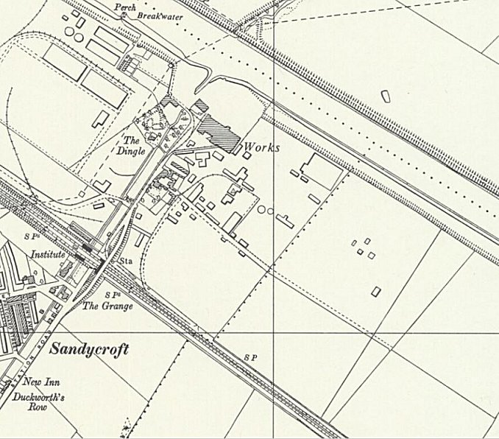
 | Ordnance Survey 1960

