Camp 575 or 576 Church Farm, Marston Moretaine, Bedfordshire

Prisoner of War Camps (1939 – 1948) - Project report by Roger J.C. Thomas - English Heritage 2003
OS NGR | Sheet | No. | Name & Location | County | Cond’n | Type 1945 | Comments
SP 9974 4049 | 153 | 575 | Church Farm, Marston Moretaine, Bedford | Bedfordshire | 4 |  | Small camp of Nissen huts on either side of road.

Location: Possible site just to the S of Church Farm with a few buildings on one side of the road shown.  Before the camp: Farmland  Pow Camp: References to Italian POWs working in nearby brickworks.  After the camp: Farmland  Further Information: | 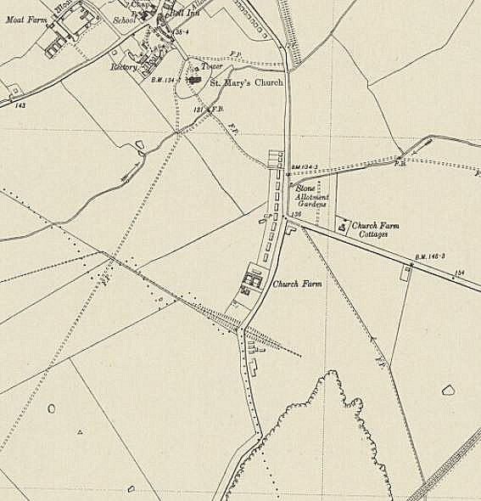
 | Ordnance Survey 1960

