Camp 575 Ashton Gifford Camp, Codford, Warminster, Wiltshire

Included in the 1945 ICRC Camp list – Labour Camp. 575. Ashton Gifford Camp, Codford, Warminster, Wilts.

Prisoner of War Camps (1939 – 1948) - Project report by Roger J.C. Thomas - English Heritage 2003
OS NGR | Sheet | No. | Name & Location | County | Cond’n | Type 1945 | Comments
 |  | 575 | Ashton Gifford Camp, Godford, Warminster | Wiltshire | 5 |  | There is a great deal of uncertainty about this site, the only Godford listed by the OS is situated in Devon.

Location: Note – the cause for the EH uncertainty was a mis-spelling of Codford as Godford.  The area of Ashton Gifford is located around NGR ST 960 400. The entry does not state Ashton Gifford House – and the House was in use as a school throughout the 1940’s  An article in the Wiltshire Times referred to the location of the camp – “Codford [Army] Camp was laid out in 1914 at Manor Farm, Codford, which is situated just off the A36 between Warminster and Salisbury. It was occupied by various army regiments during World War 1. A second camp was sited close to the original one during World War 2 for use by various regiments and the US Army. It was also used as an Italian POW camp.”  Before the camp: Farmland  Pow Camp: Italian pows.  After the camp: Polish Resettlement Corps were located at Codford, but I am not sure if they were at the same camp.  Further Information: | 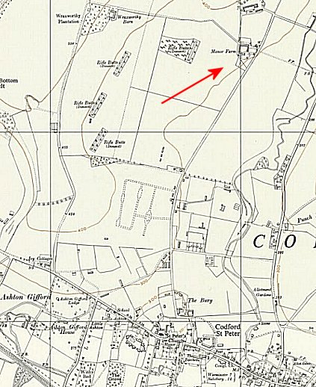
 | Ordnance Survey 1962

