Camp 574 (& 684) Hitcham Park, Burnham, Buckinghamshire

Included in the 1945 ICRC Camp list – Labour Camp. 574. Hitcham Park, Burnham, Bucks.

1947 Camp list
684(G.W.Coy) | E. | Hitcham Park Camp, Burnham, Bucks | Burnham 316 | 9(W.O.) | V/1270/4
Above entry crossed out and written in pen – “DISBANDED. Correspondence to: HP., 9 Group, Royal Pioneer Corps, c/o G.P.O. Bedford”

Prisoner of War Camps (1939 – 1948) - Project report by Roger J.C. Thomas - English Heritage 2003
OS NGR | Sheet | No. | Name & Location | County | Cond’n | Type 1945 | Comments
SU 921 826 | 175 | 684 | Hitcham Park, Hitcham Lane, Burnham | Buckinghamshire | 5 | German Working Company | Precise location not identified. NGR for approx. centre of park

Location: NGR SU 9220 8280 either side of the drive and still marked as Hitcham Park Camp on the 1961 OS map. In an article for the Taplow Society, Alan Senior recorded that the Italian pow camp was “in the field on the north side of Hitcham lane, adjacent to The Gore” – which matches the map.  Before the camp:  Pow Camp: Italian pows as camp 574. Later a German Working Company camp numbered 684.  The 1947 list shows that the camp closed in 1947.  After the camp:  Further Information: | 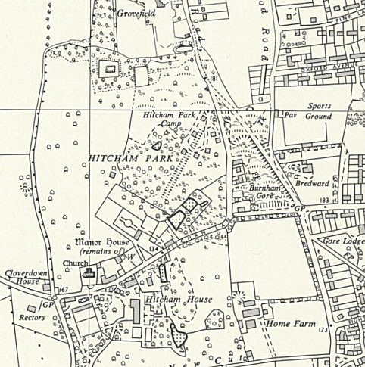
 | Ordnance Survey 1961

