Camp 573 Pendre Camp, Builth Wells, Radnorshire (aka Llanelwedd)

Included in the 1945 ICRC Camp list – Labour Camp. 573. Llanelwedd Camp, Builth Wells, Breconshire.

Prisoner of War Camps (1939 – 1948) - Project report by Roger J.C. Thomas - English Heritage 2003
OS NGR | Sheet | No. | Name & Location | County | Cond’n | Type 1945 | Comments
 |  | 573 | Pendre Camp, Builth Wells | Radnorshire |  |  | Wales

Location: A - Pendre is a small area to the W of Builth Wells – NGR SO 033 513.  B – Llanelwedd is on the other side of the River Wye, about 2 km away SO 047 519  Before the camp: Military sites recorded at Pendre during WW2. A reference to there being a Royal Artillery Practice camp in May 1942, and later US troops in Pendre.  Pow Camp: Italian pows.  After the camp: A - 2020 medical centre, residential and parkland.  B- Residential alongside the Royal Welsh Showground.  Further Information: | 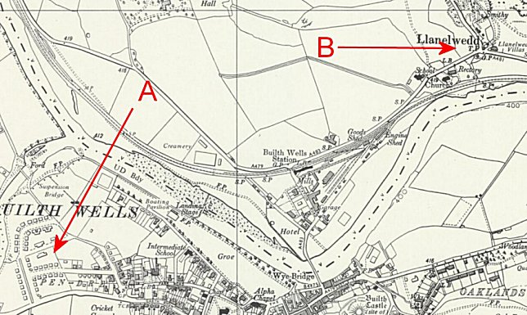
 | Ordnance Survey 1964

