Camp 572 Edwinstowe, Nr Mansfield, Nottinghamshire

Included in the 1945 ICRC Camp list – Labour Camp. 572. Address non communiqué

Location: NGR 625 674. On the edge of Sherwood Forest.  Before the camp:  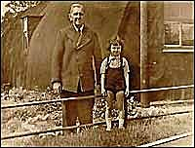  Pow Camp: Italian pows. Mixed wooden and Nissen type huts.  < Picture taken late 1940’s as a displaced person’s camp. Nissen hut in background. (BBC Nottingham, see below). Other pictures shown on the Edwinstowe site show wooden huts.  After the camp: Displaced persons camp, mainly from Eastern Europe. Agricultural hostel. 2020 play-area and parkland.  Further Information:  https://edwinstowehistory.org.uk/young-historian/one-of-the-secrets-of-sherwood-forest-veras-story/  http://www.bbc.co.uk/nottingham/features/2003/02/edwinstowe_pow_pictures.shtml | 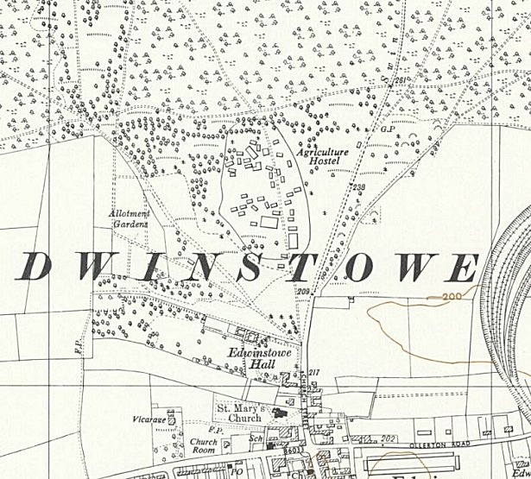
 | Ordnance Survey 1955

