Camp 571 ST2, Stranraer, Wigtownshire

Prisoner of War Camps (1939 – 1948) - Project report by Roger J.C. Thomas - English Heritage 2003
OS NGR | Sheet | No. | Name & Location | County | Cond’n | Type 1945 | Comments
 |  | 571 | ST2, Stranraer | Wigtownshire |  |  | Scotland

Location: Secret Scotland website states that this may be the large camp that was based beside Ladies Walk wit NGR 0725 6072.  Before the camp: A large military camp was located beside Ladies Walk. Mainly used as a transit camp for troops arriving on the Stranraer ferry.  Pow Camp: The aerial photograph from 1946 show at least 131 huts mainly Nissen type spread over a large area of about 23.20 hectares.  Meaning of ST2?  After the camp: Stranraer Academy and residential area.  Further Information:  Aerial photographs 106G/Scot/UK 41, 3305-3306, flown 4 May 1946  Canmore - http://canmore.org.uk/site/279894 | 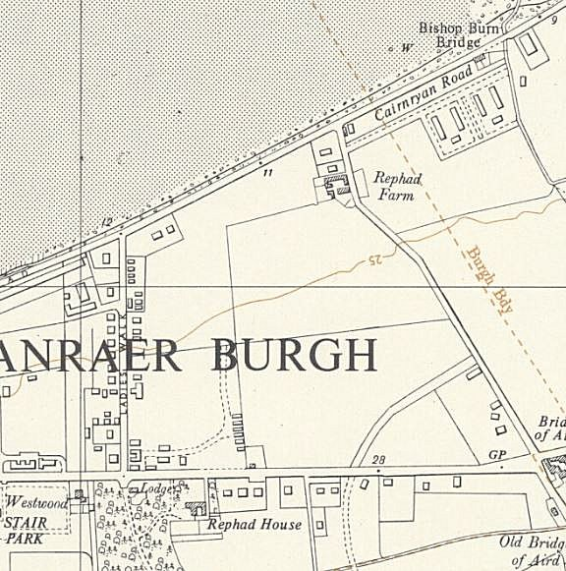
 | Ordnance Survey 1957

