Camp 571 Woodcut House, Ashford Road, Bearsted, Maidstone, Kent (aka Woodcot)

Included in the 1945 ICRC Camp list – Labour Camp. 571. Woodcot House, Ashford Rd, Bearstead, Maidstone, Kent.

Location: I think ‘Woodcot’ would be Woodcut as shown on the map, about 1 km E of Bearsted.  Before the camp:  Pow Camp: Brief references to memories of Italian pows.  After the camp:  Further Information: | 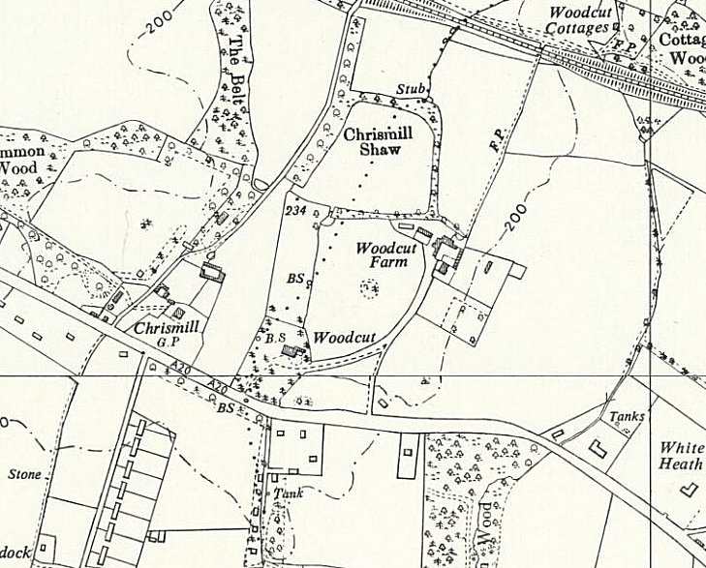
 | Ordnance Survey 1962

