Camp 570 Shardlow Hall, Shardlow, Derby

Included in the 1945 ICRC Camp list – Labour Camp. 570. Shardlow Hall, Shardlow, Derby.

Location: About 9km SE of Derby.  Before the camp: 17th C country house and small estate. Became Shardlow Hall School from 1911 to 1933. For a short time, it was a hotel. Requisitioned at the start of WW2.  Pow Camp: “The buildings at Shardlow Hall were used as a prisoner of war camp for Italian soldiers during the Second World War. This Second War World prisoner of war camp consisting of military buildings, existing buildings reused for military purposes, trackways and associated pillboxes, is visible as structures on air photographs. With the exception of the original Shardlow Hall buildings and the easternmost pillbox that are still extant, no other features are visible on Google.Earth.com 30th April 2007.” (Information from PastScape).  The nearby Dower House (81 London Road) was also believed to have been used as an extension to hold Italian pows – one of whom came back to visit in the 1980’s.  After the camp: Used by Ministry of Agriculture, Fisheries and Food. 2020 mixed use – private residence, nursery school and offices.  Further Information:  Aerial photograph - NMR RAF/106G/UK/581 4114 02-AUG-1945 | 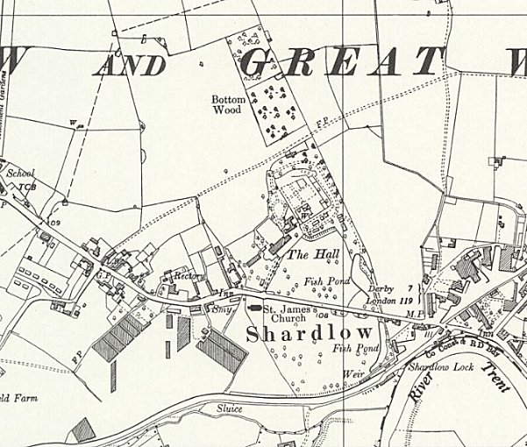
 | Ordnance Survey 1955

