Camp 569 Moreby Hall, Selby, Yorkshire

Included in the 1945 ICRC Camp list – Labour Camp. 569. Moreby Hall, Esrick, York.

Location: NGR for the Hall is SE 5958 4321. In 1945 Esrick was little more than a house and a railway station.  Before the camp: 19th C manor house and estate.  Pow Camp: 1 report that the camp may have been located in SW of estate by Home Farm.  After the camp: 2020 the Hall is a hotel. Alongside Home Farm is a caravan site.  Further Information: | 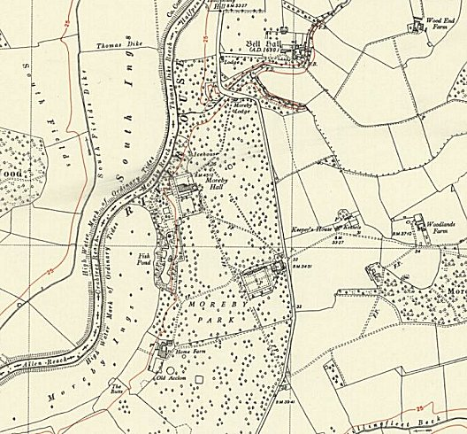
 | Ordnance Survey

