Camp 568 Basing Gate Camp, Sherfield-on-Loddon, Basingstoke, Hampshire

Included in the 1945 ICRC Camp list – Labour Camp. 568. Basing Gate Camp, Sherfield-on-Loddon, Basingstoke, Hants.

Location: ??? Map shows general area. I cannot find a ‘Basing Gate’ or any reference from the web  Before the camp:  Pow Camp:  After the camp:  Further Information:  Possibly in the nearby Bramley Military Camp?  There was a Pioneer Corps Camp next to Taylors Lane at Church End – this is close to Sherfield, but no mention of a pow camp. | 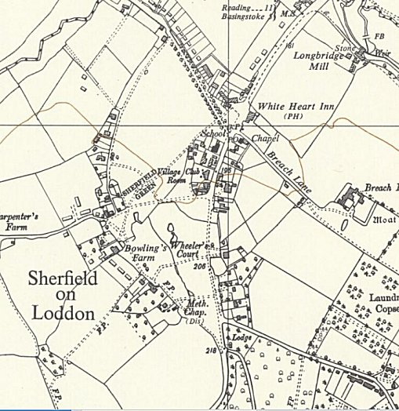
 | Ordnance Survey

