Camp 567 The Mount, Whitchurch, Shropshire

Included in the 1945 ICRC Camp list – Labour Camp. 567. The Mount, Whitchurch, Shropshire.

Location: General area for ‘The Mount’ shown on map at SJ 538 418  Before the camp:  Pow Camp:  After the camp:  Further Information:  Probably linked with Camp 567 Old Field Villa, Market Street, Craven Arms, Shropshire | 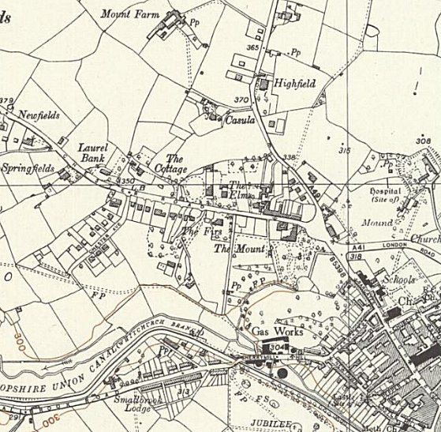
 | Ordnance Survey 1954

