Camp 566 The Grove, Worth, Sussex

Included in the 1945 ICRC Camp list – Labour Camp. 566. The Grove, Worth, Sussex.

Location: NGR for The Grove TQ 3293 3513. About 3km SE of Worth.  Before the camp:  Pow Camp:  After the camp:  Further Information: | 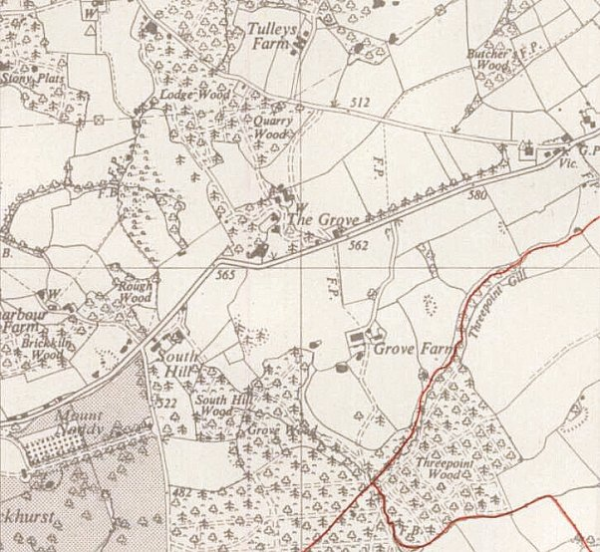
 | Ordnance Survey 1958

