Camp 566 (& 625, 660) Patterton Camp, Thornliebank, Glasgow, Lanarkshire

Included in the 1945 ICRC Camp list – Labour Camp. 660. Patterton Camp, Thornliebank, Glasgow.

1947 Camp list
660(G.W.Coy) | Sc | Patterton Camp, Thornliebank, Glasgow | Giffnock 2396 | 105(W.O.) | V/1270/4

NOTE: As there is a website dedicated to this camp – with a book that can be downloaded free of charge, I only give an outline and a few further details here.

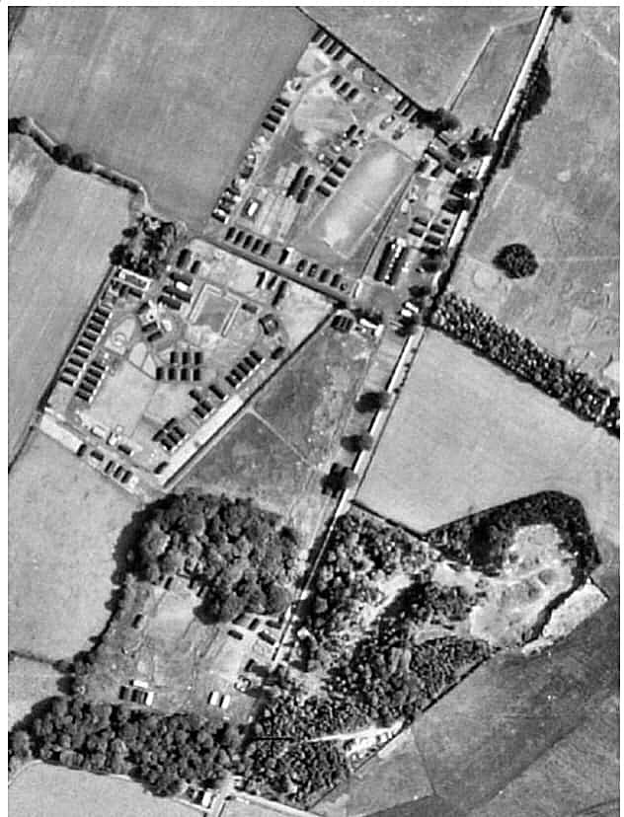  Location: NGR NS 540 583 partially shown on 1957 map.  Before the camp: Farmland. Possibly a military camp, but no evidence for this.  Pow Camp: Large camp shown in aerial photograph taken in 1946 (106G/Scot/UK 140,Pt.III 5275-77, flown 3 July 1946). The photograph and map show four sections for the camp.  Two sections – shown on the photo and map are similar to standard camp layouts with a section at the ‘front’ alongside the road, this was usually the guards’ and administrative compound. A section behind this would then have been the pow compound – a football pitch also appears in the photo.  There is an additional large area, not shown on the map by 1957. Within this area there appears to be a parade ground. The GUARD report (see below) also identifies possible areas for gardens and allotments.  To the south are further huts between two areas of woodland.  Italian pows and then German pows. Mixed hut types, most were Nissen type. | 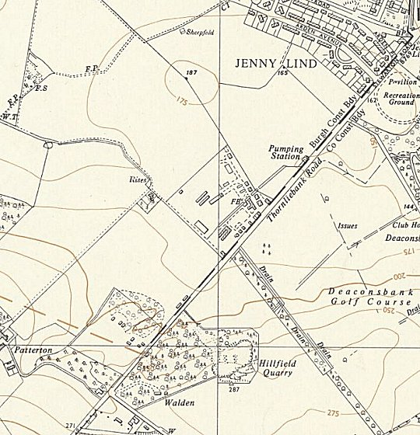
 | Ordnance Survey 1957

There are records of Italian pows at the camp in May 1944, but they may have been here before that. They were listed as co-operator pows and formed an Italian Working Company with the site as Camp 566. An Italian chapel was built inside one of the huts and the first service was held on 4 June 1944. Most of the original Italian pows were allocated to billets in the area or transferred to other areas where workers were required. Another large group of Italians were transferred from Algiers to the camp in August 1944 and formed 625, Italian Working Company. Again, these pows were gradually allocated to other sites during Spring 1945.
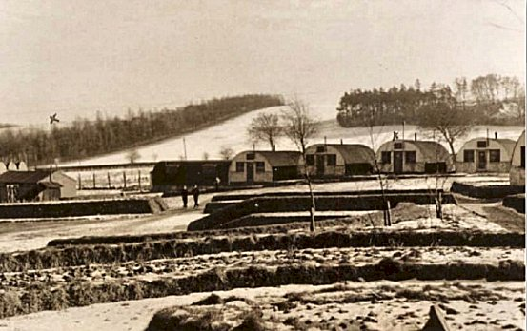
Four Italian fatalities were recorded. Soldate A Catrupi was killed in a motor accident on 9 October 1944. Sargente Bruno Zanchi was killed by a cyclist on 4 January 1945. Both of these soldiers were buried at St Peter’s Cemetry, Dalbeth where there is an Italian and Polish section for burials. On 28 December 1944 Captain Major Nalin, Corporal A Greshi, and a civilian were killed when a boiler exploded in the Grand Hall, Kilmarnock. The two soldiers were deployed to the site at the time – the Grand Hall was pow camp 557. After a public inquiry in the Sheriff Court, they were buried in Kilmarnock Public Cemetery.

During late Spring / Summer of 1945, the camp’s security was increased by the Pioneer Corps in preparation for holding German pows. The camp was re-designated as Camp 660.

The camp was inspected by the International Red Cross in November 1945 – report below.
Further inspections took place carried out on behalf of COGA (The Control Office for Germany and Austria) in relation to re-education activities, (National Archive File 939).
Camp commandant c1945 Major W M Spreckley from the Pioneer Corps. Reports from inspectors and pows show a very high regard for this man.
Two pows escaped from the camp during 1946. “P.O.W.s, 10 Days Free, Had Boat in Hide-out – Ten days after escaping from a POW camp near Thornliebank Glasgow, two Germans were captured by Largs police early yesterday.
One of the missing prisoners was seen at a fish restaurant after ten o’ clock. The police gave chase and caught him in a joiner’s yard. The prisoner who wore khaki battledress trousers and an American gaberdine jacket spoke fluent English with an American accent. He told the police he had lived in the United States for a number of years.
The man and his fellow prisoner had been living in a hide-out in the woods on Kelburn estate between Largs and Fairlie. In the early hours of yesterday morning the police rounded up the second prisoner in the woods.
The prisoners had a collapsible rubber dinghy in their hide-out, and said they had been trying to escape to Ireland. The English-speaking prisoner claimed that he and his companion had rowed out in their dinghy t the Clyde river steamer, King Edward, and, under the impression that it was a ship going to Ireland had climbed aboard. On learning the identity of the vessel, they left it. The men would not attract particular attention as their clothes are similar to those worn by many hikers.” (The Courier, 23 April, 1946).

The last pows left on 29 June 1947.
After the camp: Polish resettlement camp. Emergency housing. 2020 residential area.
Further Information:
https://www.pattertonpowcamp.co.uk/ - Focusing on Patterton Camp, this intergenerational oral history project has captured much of the history of the camp and its impact on local people between 1939 and 1959. Excellent site that even has a free book! Includes recorded memories.

National Archive – FO 939/188 – 660 Working Camp, Patterton Camp, Thornliebank, Glasgow. Dated 1945-1947
Canmore - http://canmore.org.uk/site/206287
Archaeological evaluation – Glasgow University Archaeological Research Division - GUARD 2004, RCAHMS MS 2320.

https://www.facebook.com/Patterton-WWII-A-POW-Camp-its-Neighbours-249166905763108/

B/PEB/JRh/MBG Translation - Great Britain  WORKING COMPANY 660.  Visited on November 17, 1945 by Mr. Bieri.  Address: 660 GPWW Coy, Great Britain.  Commandant: Major W.M. SPRECKLEY.  Camp Leader: BUSSMAM Wilhelm, "Wachtmeister", B 115646.  Assistant: BUSTINGHAUS Wilhelm, "Feldwebel", 736314.  Capacity: 700 men  Strength: 535 German prisoners, including 1 officer, 49 warrant officers, 32 protected personnel and 16 patients in a nearby hospital, - distributed in the following way:  406 Army  69 Navy  58 Air force  1 of the Todt organization  1 civilian  More than 500 prisoners of this camp were transferred from Camp 200 and all, (except a member of the protected personnel who was captured on November 5, 1942 in Africa), are prisoners since D-Day.  General information and accommodation  The camp, located on a slope close to a large city, is composed of huts connected by pathways. It was built ready to house Germans from 25 May 1945, with a design that works very well. The 59 huts are used in the following way:  dormitories (on average 20 men per hut) 26  classrooms 2  theatre 1  chapel 1  canteen 1 |  | refectory 1  infirmary 3  showers 3  wash-hand basins 3  latrines 2  large kitchen with bakery 1  stores with provisions 2  bread storehouse 1  hut for teachers and interpreters 1  artists workshop 1  tool storehouse 1  office 1  hairdresser 1  craft workshop 3  carpentry 1  quarter-master’s hut 1  All of the huts have electric lighting and are heated by stoves. Each man receives a sleeping bag and a blanket.  Sanitary facilities  These installations are good (showers with hot and cold water and flushing toilets).  Food  The menu for the day following our visit:  Breakfast: porridge, marmalade, bread.  Packed Lunch: bread, ham, tea.  Dinner: hot-pot with vegetables.  Medical care  The infirmary is composed of 3 wooden huts (dormitory of 12 beds, dispensary, etc), but their installation is not yet finished. It was necessary to refurbish the dormitory for winter and, during this work, the patients were sent to hospital or their huts as was the case for two prisoners (heart trouble and influenza).  Officer/German doctor: NATHO Richard, "stabsarzt" B 123054.

There are sufficient medical supplies. General medical inspections take place from time to time and, on average, 15 to 20 prisoners are seen each day.  A British dental surgeon provides dental care.  There were no cases of serious disease, contagious or epidemic.  Prisoners are authorized to go for walks. There were no complaints about the medical department.  The German officer-doctor considers that the state of health and nutrition of the prisoners is good, (while noting that the climate will not make it possible for prisoners to maintain good health for too long).  Clothing  All necessary distributions had been made, some large coats will be needed. Approximately 50% of the prisoners had their German uniform, but in very bad condition.  Work  The majority of the prisoners work in workshops. On average, 320 can work each day and forty can earn up to 1½d per hour, the others, ¾d. Prisoners who are not specialists earn on average from 2/- to 6/- per week.  Canteen  The canteen is well supplied and it has missed only polish for 6 weeks. The welfare fund has reached approximately £80.  Religious services  The protestant chaplain CREMER Hans Joachim, "Obergefreiter” A 978166 leads worship every Sunday for 100 to 120 prisoners. Forty men attend bible meetings which take place during the week.  There is no catholic priest within the camp. A local priest comes every Sunday to celebrate mass.  Leisure  The prisoners have a football field. |  | The camp library has approximately 140 books, of which a hundred are novels, but there are not enough textbooks. The director of studies, POUSSET Emil, "Oberkannonier", B 381283, has organized the following courses:  Pupils  English 75  German 15  arithmetic 15  mathematics 10  natural science 10  accountancy 10  shorthand 5  The theatre company has a dozen actors, who are preparing a Christmas show.  There is no orchestra, but they have a violin and a radio.  The choir has 30 to 35 members.  Since the beginning of August, a film show takes place each week.  Correspondence  On September 19, 1945, 366 brown cards were dispatched to:  193 in the British zone  119 in the American zone  54 in the French zone  In addition to the replies already received, 50 letters have arrived from countries other than Germany, and 5 from Germany, all since 25 May 1945. The Commandant affirmed to us that the prisoners’ morale has improved since the first replies to the brown cards arrived. Only a few prisoners received bad news.  161 prisoners cannot make use of these cards:  123 who have family living in the Russian zone  23 who have family living in Berlin  15 who have family living in Czechoslovakia.  Conclusion  This camp is excellent in all regards and no-one raised any complaints  [Translated and partly abridged – M Sanders]  Brown cards refer to cards that prisoners sent to inform families of their whereabouts.

