Camp 565 (& 650) Rufford Abbey, Ollerton, Newark, Nottinghamshire

Included in the 1945 ICRC Camp list – Labour Camp. 565. Rufford Abbey, Ollerton, Newark, Notts. Also Labour Camp. 650. Same address.

Location: 4km S of Ollerton. Huts to be seen just to the W of the main abbey building at SK 6440 6475, shown in outline on the map.  Before the camp: Cistercian Abbey then part of a country mansion and estate. Requisitioned in 1939. Used by the army to station troops in about 20 huts up to D-day.  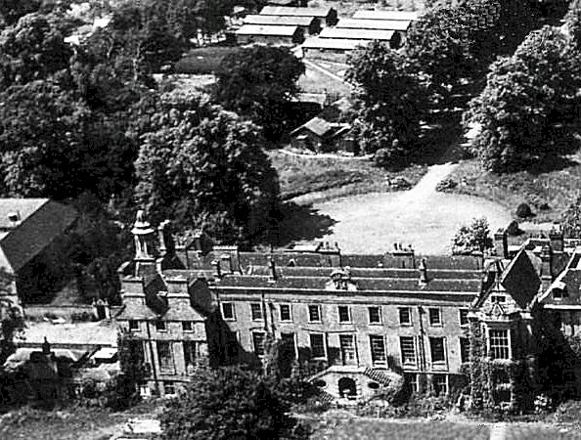  Pow Camp: The picture shows wooden type huts in the background. Low security.  Italian pows.  Reports that the pows were able to enter the Abbey where they removed the tapestries to make bags.  After the camp: Huts used for a while for Civil Defence purposes before being demolished. 2020 part of Rufford Country Park.  Further Information: | 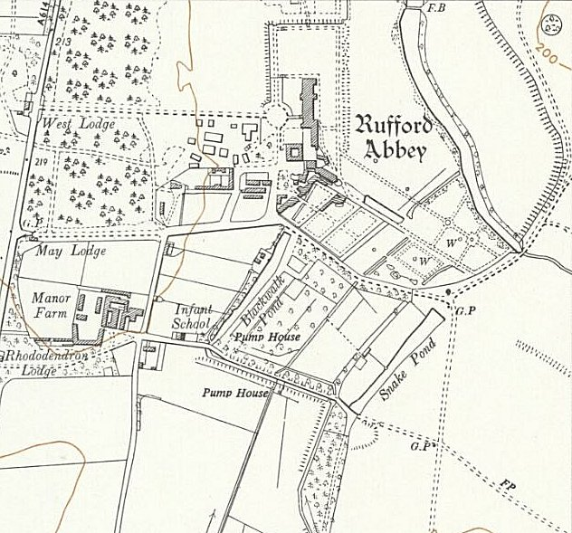
 | Ordnance Survey 1955

