Camp 564 Stretton Hall, Staffordshire

Prisoner of War Camps (1939 – 1948) - Project report by Roger J.C. Thomas - English Heritage 2003
OS NGR | Sheet | No. | Name & Location | County | Cond’n | Type 1945 | Comments
SK 3051 1198 | 128 | 564 | Stretton Hall, Stretton-en-le-Field,  Neatherseal | Staffordshire | 5 |  | Precise location not identified, NGR  given for Hall Farm.

Location: ?  Map 1 - The entry above is for a location that is not in Staffordshire and does not seem to have a Hall. The NGR is for Home Farm and not Hall Farm.  Map 2 - There is a Stretton Hall in Stretton, Staffordshire at SJ 887 117  Before the camp:  Pow Camp:  After the camp: Stretton Hall is now a care home.  Further Information: | 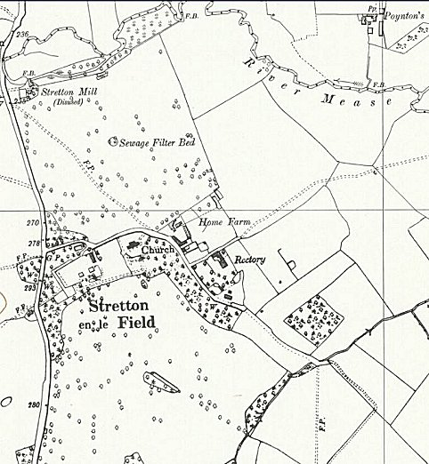 | 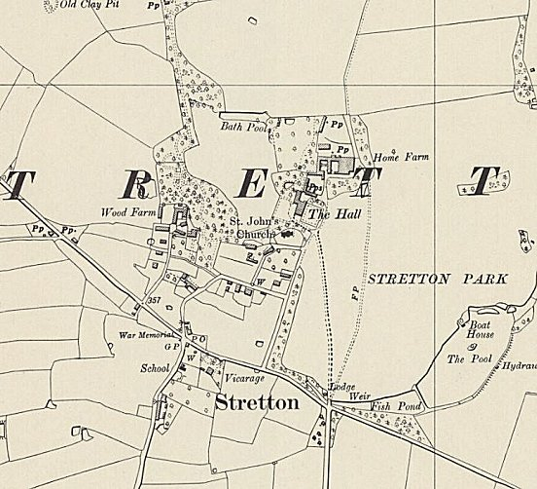
 | Ordnance Survey 1954 Map 1 | Ordnance Survey 1954 Map 2

