Camp 564 Stable Road Camp, Barlow, Yorkshire

Included in the 1945 ICRC Camp list – Labour Camp. 564. Stable Road Camp, Barlow, Selby, Yorks.

Prisoner of War Camps (1939 – 1948) - Project report by Roger J.C. Thomas - English Heritage 2003
OS NGR | Sheet | No. | Name & Location | County | Cond’n | Type 1945 | Comments
SE 651 283 | 105 | 564 | Stable Road Camp, Barlow | Yorkshire | 4 |  | Camp associated with Barlow Ordnance Depot.

Location: Alongside the massive Barlow Ordnance Depot. The edge of the Depot is just shown on the bottom right of the map.  Before the camp: During WW1 an airship factory was built to the east of the village of Barlow. This site later became a Royal Ordnance Depot in the 1930’s.  Pow Camp: The York Press reported that the first pows arrived at the camp in 1943 – Italian and then German pows.  After the camp: 2020 part residential, part field.  Further Information: | 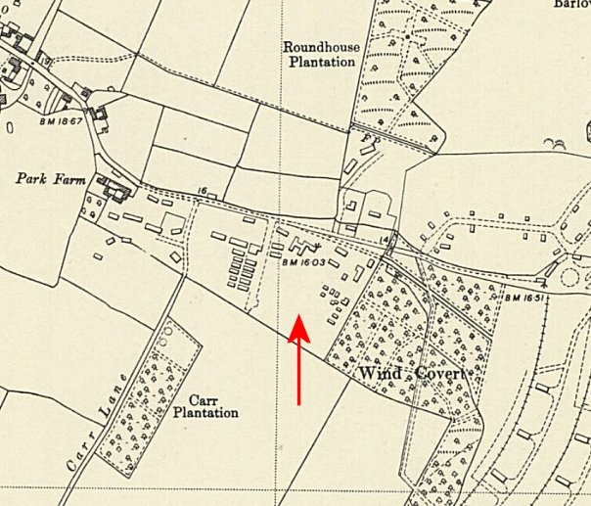
 | Ordnance Survey 1953

