Camp 563 Middleton Hall, Middleton-on-the-Wolds, Driffield, Yorkshire

Included in the 1945 ICRC Camp list – Labour Camp. 563. Middleton Hall, Middleton-on-the-Wolds, Driffield, Yorks.

Location: Approximate centre of estate park SE 948 489  Before the camp: Country house and parkland.  Pow Camp: Reported to have opened in 1943 – BUT, the source stated it was for German pows and at that date it is unlikely.  After the camp: Hall demolished in the 1960’s.  Further Information: | 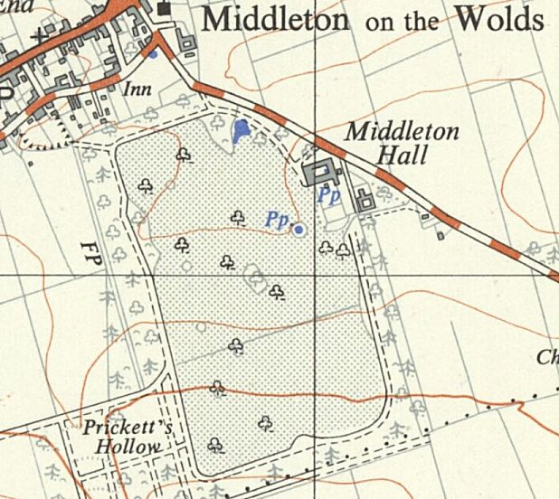
 | Ordnance Survey 1953

