Camp 561 (& 583) Old Woodbury Hall, Gamlingay, Sandy, Bedfordshire

Included in the 1945 ICRC list – Labour Camp. 561. Address non communiqué / also as 583, Old Woodbury Hall, Woodbury Park, Gamlingay, Sandy, Beds – presumably the camp number was changing as their list was being compiled.

Prisoner of War Camps (1939 – 1948) - Project report by Roger J.C. Thomas - English Heritage 2003
OS NGR | Sheet | No. | Name & Location | County | Cond’n | Type 1945 | Comments
TL 2136 5286 | 153 | 561 | Old Woodbury Hall, Gamlingay, Sandy | Bedfordshire | 5 |  | Large country house, no obvious indication of additional accommodation.

Location: The camp was in the grounds of the Hall / House. About 2.5km NWW of Gamlingay.  Before the camp: 19th C Country house and estate.  Pow Camp: Italian Working Company in April 1945. Short lived as an independent camp as it was listed as a satellite German Working Camp for Potton Camp 269 by November 1945.  After the camp: 1986 the House became Grade II listed.  Further Information: | 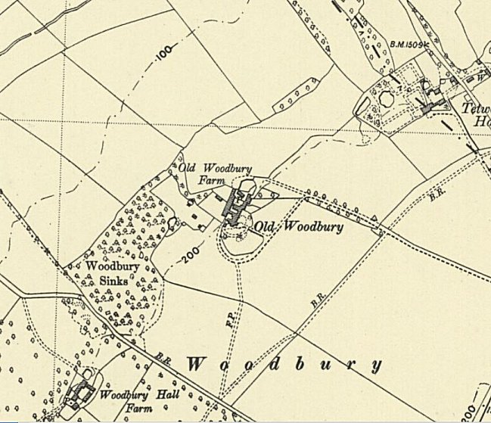
 | Ordnance Survey 1950

