Camp 560 Newton Camp, Bosherston, Pembroke

Included in the 1945 ICRC Camp list – Labour Camp. 560. Newton Camp, Bosherton, Pembroke, S.Wales.

Location: NGR SN 6161 2242. The almost rectangular shape beside the driveway shows the perimeter of the camp on the OS map. The large house beside the site marked as Dynevor Castle, (this would seem to be an error on the map) is Newton House.  Before the camp: Country house and estate. Huts built to provide part of a British, then American, military hospital, Casualty Clearing Station No 12.  Pow Camp: POWs at Newton from 1944-5 until 1948.  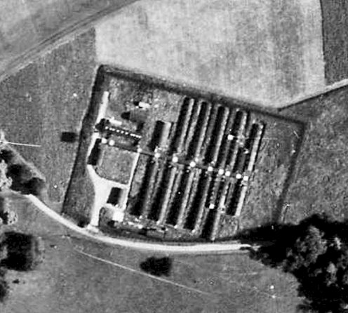  HER description – “A group of about 15 Nissen Huts stood in the parkland in front of Newton House during the Second World War, originally provided as part of a military hospital. Towards the end of the war, these were used as a Prisoner of War camp allegedly for high-ranking German officers.”  A short detail about the pows at the camp makes me wonder how long high-ranking officers were here – “They were well liked. During the great snow of 1947, the POWs cleared the length of The Walk (about 300m) and carved out snow houses in the drifts which local children loved” - Hall, J & Sambrook, 2004 Llandeilo Fawr Heritage Audit.  After the camp: Used as emergency housing, the site was known as ‘Tin Town’. 2020 National Trust property. | 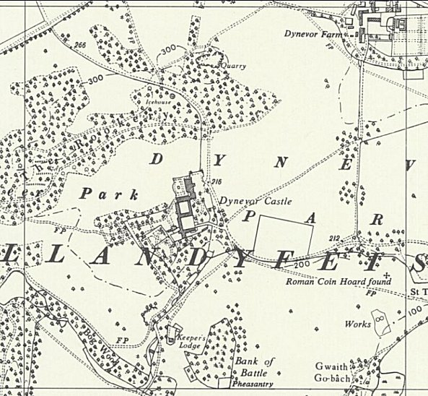
 | Ordnance Survey 1964

Further Information:

National Trust Archive at Newton House has a plan of the site.

Aerial Photograph 1946 106G/UK1625 2140

