Camp 558 Bruna Camp, Stromness, Orkney, (aka Bruno – incorrect spelling)

Included in the 1945 International Red Cross List – Labour Camp. 558. Bruna Camp, Stromness, Orkney.

Location: Near to Bruna Fea hill (HY 2660 1057) shown on map – there is also a Bruna Cottage  Before the camp:  Pow Camp: Apart from the listing in the ICRC list above, there is a brief mention of the camp in the book ‘Churchill’s Prisoners’: “There were, however, other Italians elsewhere in Orkney. After the Italian capitulation in September 1943, about sixty P.O.W. were billeted with the Royal Pioneer Corps at Bruno camp near Stromness, and were engaged mainly on dock labouring and similar tasks.”  A local resident informed me that her mother talked of Italian pows in a camp to the north of Stromness.  After the camp:  Further Information:  Churchill's Prisoners: Italians in Orkney 1942-1944 – James MacDonald – 1987 | 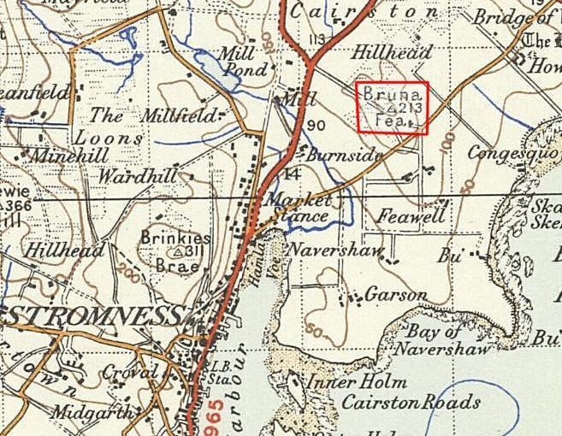
 | Ordnance Survey 1948

